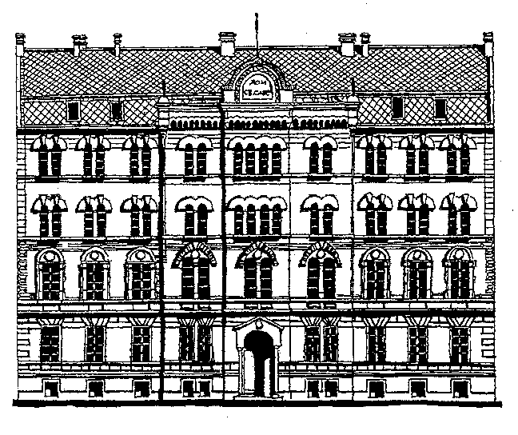 | DOCTORAL STUDIES |  | Number of application  (only for Student Services)
APPLICATION FOR DOCTORAL STUDIES |  |  | School year  20___/20___
Personal information
Name  Surname |  | Pole female male  number of passport
Contact
Address |  | city  Zip  Phone  E-mail
Sign in study programs and scientific fields
- Doctoral studies of physics  - Quantum, mathematical and nano physics  - Quantum fields, particles and gravity  - High energy physics and nuclear physics  - Physics of atoms and molecules  - Photonics and lasers  - Physics of ionized gases and plasam  - Condensed matter physics and statistical physics  - Applied physics  - Teaching physics |  | - Doctoral studies of meteorology  (Circle the number of the desired degree program, or the letter of the desired field of science)
Proposal mentor doctoral studies
Name  Surname |  | Scientific field  Institution

Attachments to the application
When applying for PhD degree originals are made available to, and the application shall be accompanied by copies. Tick ​​the box next to the filed document:

- Short professional biography - CV
- Undergraduate diploma
- Supplemente of undergraduate diploma
- Master's diploma
- Master's diploma supplemente
- Magister of science diploma

Date | Signature of applican t

